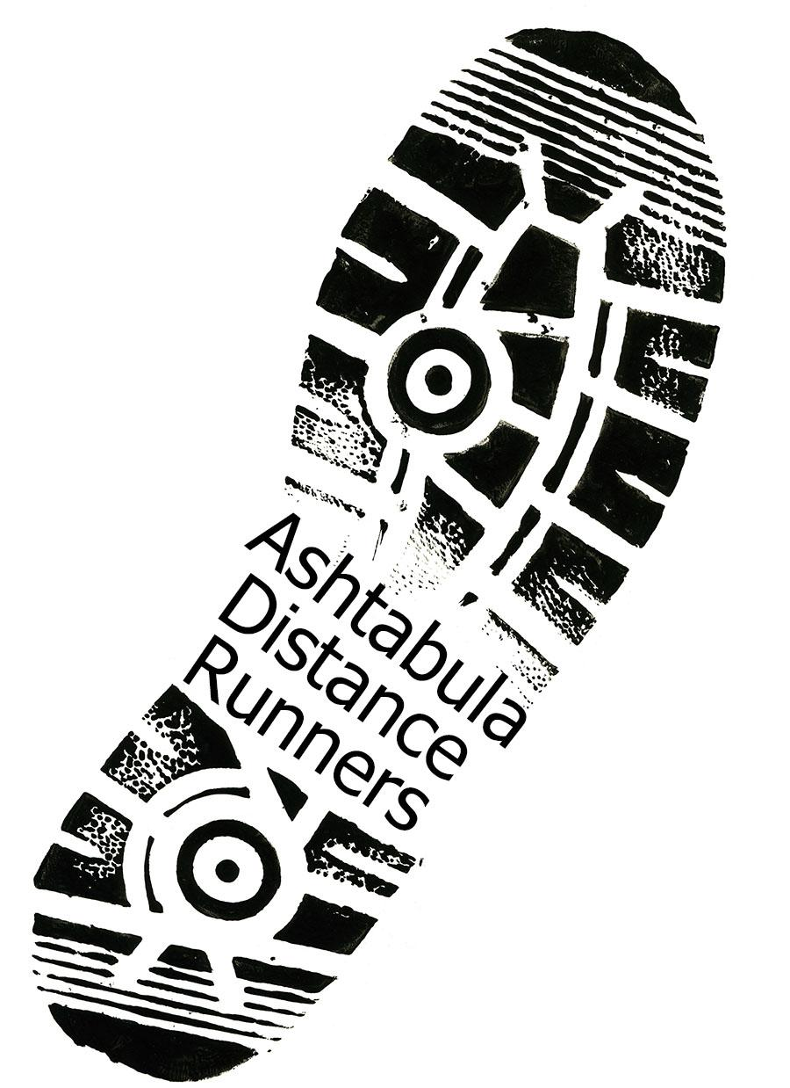

Ashtabula Distance Runners Club (ADR)

2018 Membership Application

Ashtabula Distance Runners Club is a nonprofit 501(c)(3) organization. Our primary goal is to encourage health and fitness among our members and those participating in our events. The group started in 1992 with five road races. Over the years’ the number of races on our schedule has increased significantly with dozens of charities raising proceeds through their efforts. Our high school scholarship fund has donated thousands of dollars to college-bound students and will continue to do so. Our club members are comprised of all levels of physical ability and age.

Membership will entitle you to:
• ADR apparel and/or select merchandise • Discounts to designated club races and local running shops
• Opportunity to compete in the ADR Grand Prix race series with awards for overall and age group winners
• Social events such as annual banquet, group runs, and outings • Opportunity to serve on the Board and/or help with activities • We urge you to consider joining us this year!

The annual ADR membership fee is $20 for individuals and $25 for an entire family (household) for one calendar year.

_________________________________________________________________________________________
2018 ADR Membership Application - Expires 12/31/18
Membership: Dues Enclosed $20 Individual ( __ ) $25 Family ( __ )
Primary Member__________________________________ Date of Birth_________ Male____ Female____
Address________________________________________ City_________________ State______ Zip_______
Phone #1_______________________________________ Phone #2_________________________________
Shirt Size (S, M, L, XL) _______ E-mail address ________________________________________________
Family Member__________________________________ Date of Birth_________ Male____ Female____
Family Member__________________________________ Date of Birth_________ Male____ Female____
Family Member__________________________________ Date of Birth_________ Male____ Female____
For additional information contact Terry Putt 440-474-3925 (text), or website: ashtabuladistancerunners.org

Mail to: ADR, PO Box 43, Ashtabula, Ohio 44005. Checks Payable to: Ashtabula Distance Runners Club

Waiver: I understand that running/walking and volunteering to work in club races are potentially hazardous activities. I should not enter and run/walk in club activities unless I am medically able and properly trained. I agree to abide by any decision of a race official relative to my ability to safely complete the run/walk. I assume all risk associated with running/walking and volunteering to work in club races including, but not limited to, falls, contact with other participants, the effect of the weather, including high heat and/or humidity, the conditions of the road and traffic on the course, all such risks being known and appreciated by me. Having read this waiver and knowing these facts, and in consideration of your acceptance of my application for membership, I, for myself and anyone entitled to act on my behalf, waive and release the Ashtabula Distance Runners Club and all sponsors, their representatives and successors from all claims or liabilities of any kind arising out of my participation in these club activities even though that liability may arise out of negligence or carelessness on the part of the persons named in this waiver.

Primary Member Signature ___________________________________________ Date___________

